

Chalique nail studio information system

HELP manual

Table of Contents

Getting Started 1

Logging in 1

Making a booking 2

Edit booking 3

Cancel a booking 3

Finish a booking 4

Managing Employees 4

Managing Clients 6

Admins 8

Adding Expense Types 8

Adding, Editing and deleting an Expense 9

Changing Payments 11

Adding and deleting treatments 12

Overall view of Income and Expenses 13

Generating Report 14

Extra features 14

Email system 14

Backup system 14

Backgrounds 15

# 

# Table of Figures

Figure 1 - Log in form 1

Figure 2 - Main booking form 2

Figure 3 - New Booking 2

Figure 4 - Finish booking form 4

Figure 5 - Type of Employee 5

Figure 6 - Adding New User 5

Figure 7 - Removing User 6

Figure 8 - Edit Clients 6

Figure 9 - Delete Clients 7

Figure 10 - Expense Types 8

Figure 11 - Changing Expenses 9

Figure 12 - Changing Payments 10

Figure 13 - Treatments 12

Figure 14 - Expenses and Incomes 13

Figure 15 - Example Report 14

# Getting Started

Chalique Nail Studio is a system for a small nail salon to be used by owners and employees throughout the business. The systems allow technicians to add clients and bookings and successfully manage transactions. The system also makes it possible to manage employees as well as clients. It is also capable of managing expenses as well as generate an income and expense report on demand.

# Logging in

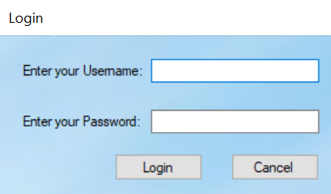Enter your credentials and click *login* to gain access to the main program. Please note: After 3 failed attempts, an email will be sent to the owner notifying them of the failed login. In addition to the sent email, the program will be terminated.

Figure - Log in form

# Making a booking

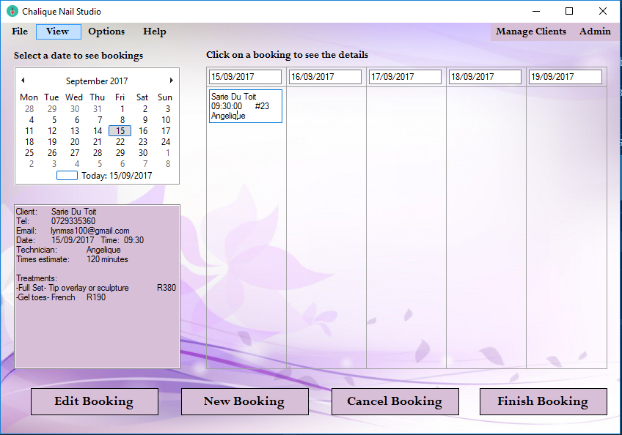

Figure 2 - Main booking form

Click the *New Booking* button to open the new booking form

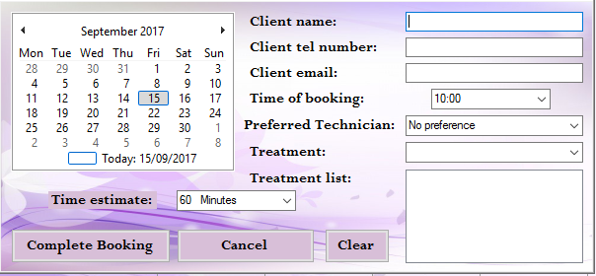

Figure 3 - New Booking

Enter the clients’ credentials as well as the details of the booking. Note that several treatments can be added using the dropdown list provided.

* *Complete booking* completes the initial booking and adds it to the booking columns in the previous form.
* *Cancel booking* cancels the booking and returns to the previous form.
* *Clear* removes all the added details from form.

# Edit booking

Select a booking you wish to edit. When booking is selected, the remaining buttons on the form will appear.

* Select the Edit booking (with a booking selected from the bookings columns) to open the new booking form with all of the current details of the booking.
* Change the details of the booking you wish to edit.
* Click Complete Booking to update details and return to the previous form.

# Cancel a booking

If you wish to cancel a booking:

* Select the booking which you want to delete.
* Click the *Cancel* Booking to delete booking.
* A message will be displayed to confirm that you wish to cancel the booking.

# Finish a booking

Click *finish booking* to proceed to the finish booking form.

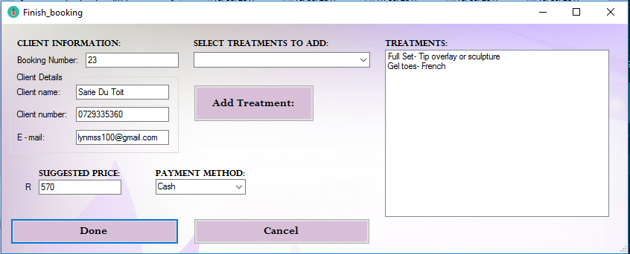

Figure 4 - Finish booking form

* Confirm clients’ details and select payment method.
* (Optional) Select any additional treatments that were added during the treatment and click *Add Treatment* to add it to the treatments list.
* Click *Done* to confirm payment and return to previous form.
* Click *Cancel* to cancel payment.

# Managing Employees

Under Options on the Main form, Select *Employee Options* to add or remove employees from the system. Note that administrative login is required in order to access the Employee Options form.

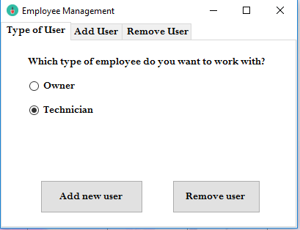

Figure 5 - Type of Employee

Select which type of employee to add or remove and click *Add new user/Remove user*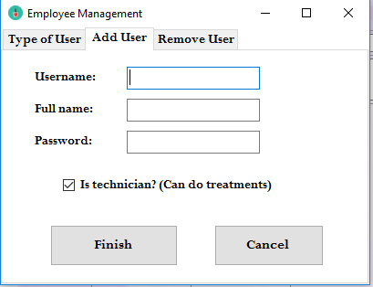

Figure 6 - Adding New User

To add Employee:

* Enter credentials of new employee.
* Tick whether the person is a technician or not
* Click *Finish* to add new user and return to previous form.
* Click *Cancel* to return to previous form without adding new employee.

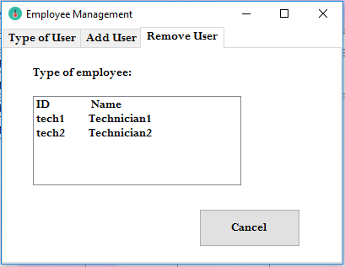

Figure 7 - Removing User

To remove Employee:

* Select employee to remove (*Remove* will display when employee is selected)
* Click *Remove* to delete selected employee.
* Click *Cancel* to return to previous form.

# Managing Clients

Click *Manage Clients* on the main form to display the Client Management form.

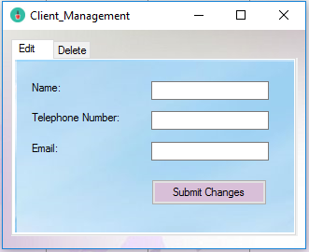

Figure 8 - Edit Clients

To Edit Clients:

* Enter Client full name which will be edited.
* Enter NEW client telephone number and Email. (Last step on next page)
* Click *Submit Changes* to update client details.

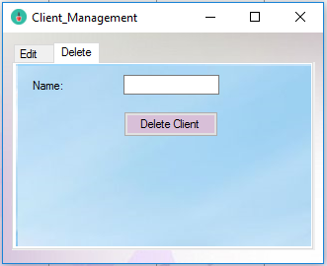

Figure 9 - Delete Clients

To delete Clients:

* Select the Delete tab.
* Enter Client name which will be deleted.
* Click *Delete Client* to permanently delete Client.

# Admins

The Admin form can be accessed through the *Admin* button on the top right corner of the main bookings form. Please note that this form can only be accessed by the owner(s).

## Adding Expense Types

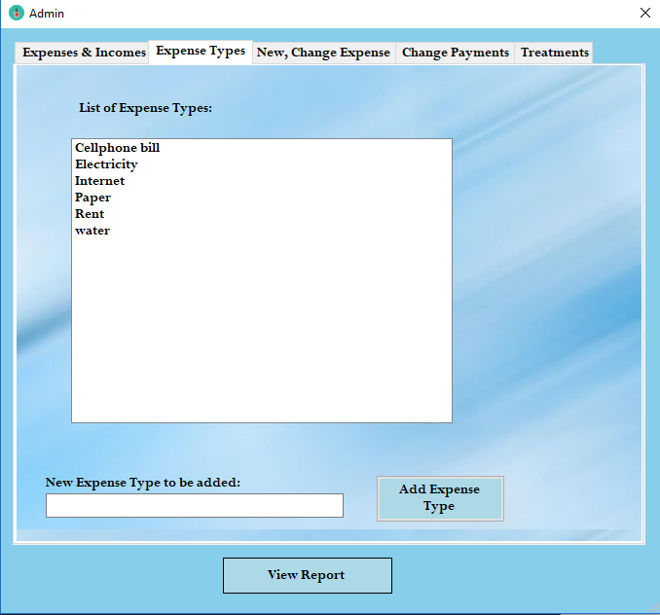

Figure 10 - Expense Types

To add Expense type:

* Enter the Expense name in the provided textbox.
* Click *Add Expense Type* to add the expense to the above list.

## Adding, Editing and deleting an Expense

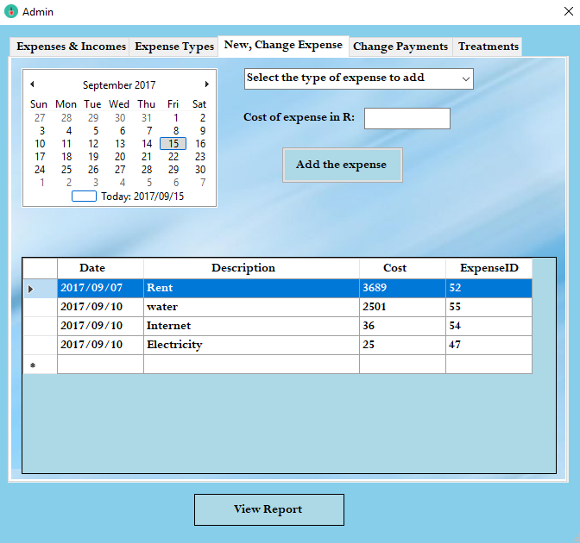

Figure 11 - Changing Expenses

To add Expense:

* Select the date on the calendar.
* Select which expense to add.
* Enter the amount of the expense
* Click *Add the expense* to add the new expense to the list.

To edit Expense:

* Select the expense (2 buttons will display when expense is selected).
* Click *Edit expense.*
* Change the details of the expense and click *Update expense* to update selected expense in the list.

To delete Expense:

* Select expense to delete from list.
* Click *Delete expense* to permanently delete expense from list.

## Changing Payments

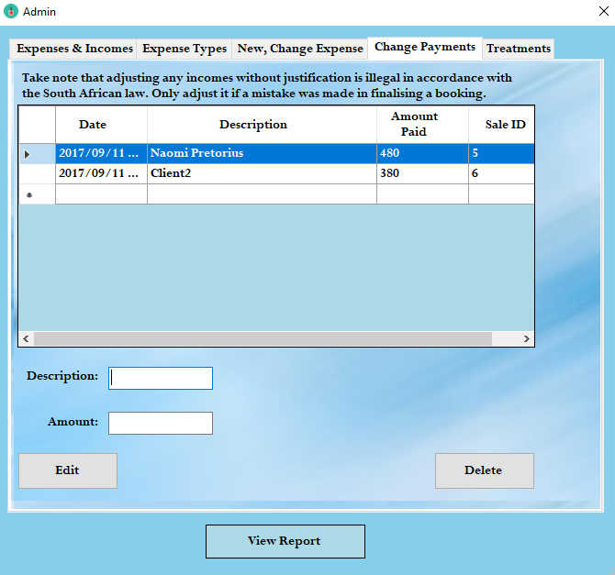

Figure 12 - Changing Payments

To Edit a Payment:

* Select payment in the payment list.
* Click *Edit* to fill Description and Amount with current details (*Update* will appear).
* Edit the amount.
* Click *Update* to add newly updated details to list.

# Adding and deleting treatments

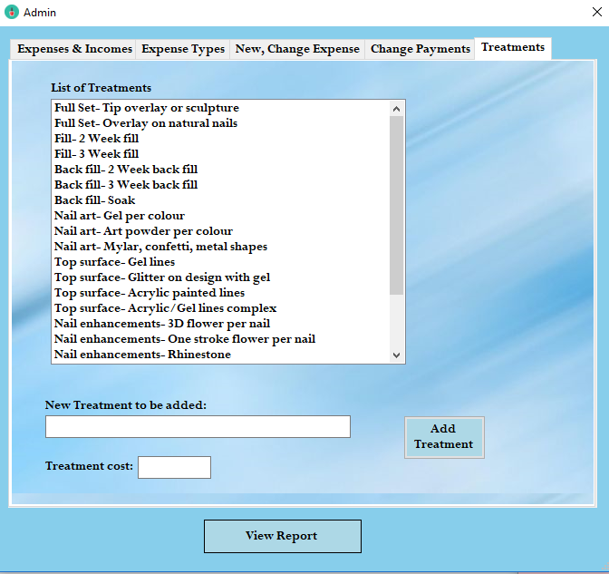

Figure 13 - Treatments

To add Treatment:

* Type the new treatment and its price into the given fields.
* Click *Add Treatment* to add the new treatment to the list

To delete Treatment:

* Simply double click on a treatment in the list to permanently delete it.

## Overall view of Income and Expenses

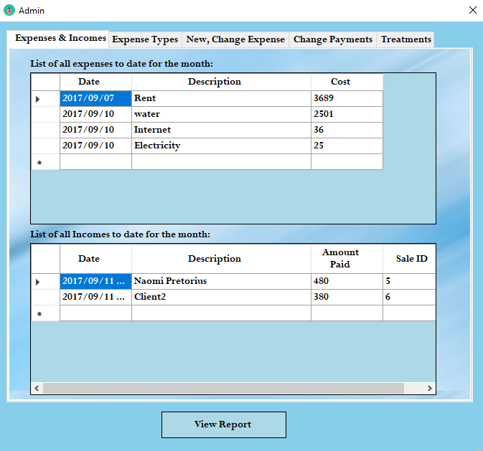

Figure 14 - Expenses and Incomes

This is an overall view of the current Income and Expenses in the company. Any new or updated Items will appear in these 2 lists. Deleted Items will be removed.

## Generating Report

Simply click the View Report to Generate a Report on the current Income and Expenses. On the Report form, there are options to print, export or save Report.

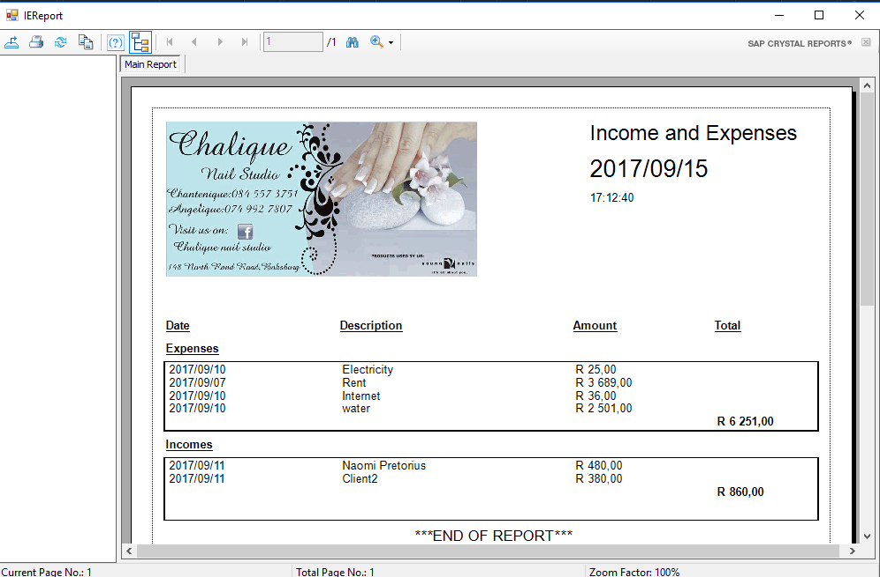

Figure 15 - Example Report

# Extra features

## Email system

The system can send an email after every booking. To edited the message that is sent, simply click the *Change Email Message* under the *Options* on the main booking form.

## Backup system

The program will automatically prompt you to add backup folder if you have not done so. To do this, simply follow the steps when prompted. The location of the backup can also be changed by clicking *Change backup location* under the *Options* tab on the main booking form. The backup system can also be turned off by clicking *Toggle backup* under *Options* on the main booking form.

## Backgrounds

Different backgrounds can be selected by clicking *View* followed by *Background* and then selecting the desired option.